Anglais Technique

*Cours n°3*

Exercice - Present Perfect

*Voir Annexe: *

«ed»

3 sounds for «ed»

The pronunciation of the final -ed in a word depends on wheteher the sound before -ed is **voiced** or **voiceless**

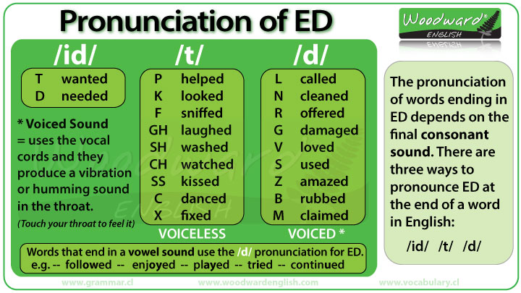

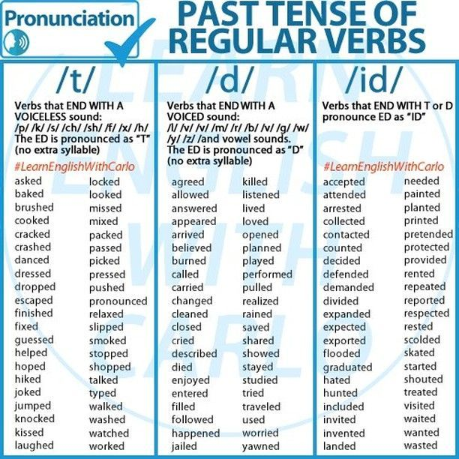

*Exercice*

Exercice - Job

Piocher un job et utiliser Internet pour avoir sa description

**Cloud Architect**

Job description:

* Overseeing an company’s cloud.
* Oversee application structure and deployment cloud environements.

Job activites:

* They have to interact with different teams (*DevOps engineers, developers, ...*) to keep operations running smoothly.
* Convert the technical requirement into the architect structure and design the guide final product.

Salaries:

How much do they make/earn ? Average 6.250euro/months or 75.000euro/years.

Is it an indemand job ? Yes, 67% of enterprise have an cloud architect.